Detailed Agenda

 | Presentation | Participants
10:00 am | Moderator’s introduction
10:05 am | Welcome Speech | Chairman of the Board, PAIH  Andrzej Dycha
10:10 am | Welcome Speech | Etienne de Poncins,  French Ambassador in Poland
10:15 am | France, an attractive environment for foreign investors | Alexandre Kühl & Adeline Dohin (BF)
10:30 am | Expertise for a successful investment in France | GIDE
11:00 am | Success stories and investors’ testimonies | I / II
11:30 am | Q&A | Moderator
12:00 am  13:00 pm | Networking Cocktail

BUSINESS FRANCE SPEAKERS

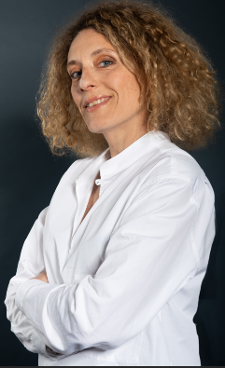 | Biography Adeline Dohin, Business France:  As the Head of Investment department for Business France DACH, Benelux & CEE, Adeline has been leading a team of 13 persons since September 2023. With experience in the public and private sectors, in China and Europe, she has held management positions in the cultural and economic sectors. Adeline defines the prospecting strategy, supports investors in their projects in France and participates in promoting the attractiveness of France through communication & events. With a degree in political science, she focused on international studies and foreign languages ​​(Mandarin and German) and followed the MBA program at Sun-Yat-Sen University in Canton (China).
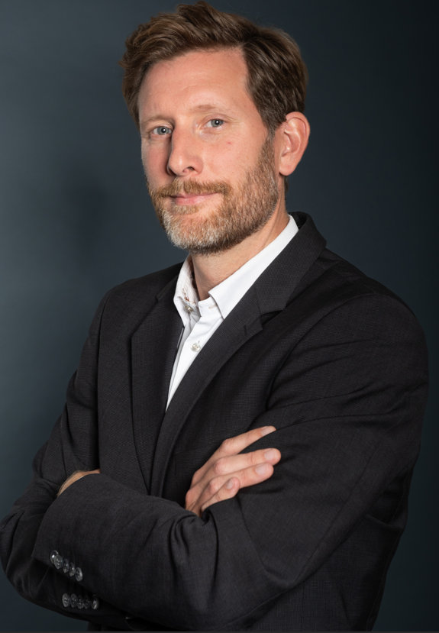 | Biography Alexandre Kühl, Business France:  As a a senior investment advisor, Alexandre has been supporting companies in the realisation of investment projects in France for over 15 years. Since 2024, he has been responsable for the Baden Württemberg and Poland territories. Alexandre has a degree in business administration (PFH Göttingen).

